In Databricks, the term clustered usually refers to clusters, which are fundamental to how Databricks executes workloads. Here’s what it means and why it’s useful:
✅ What is a Cluster in Databricks?
A cluster is a set of computing resources (virtual machines) that Databricks uses to run your notebooks, jobs, and queries. It provides the processing power for:
- Data engineering (ETL pipelines)
- Data science (model training)
- Analytics (SQL queries, dashboards)
Clusters are managed by Databricks and can be auto-scaled based on workload.
Uses of Clusters in Databricks
- Compute Environment
Clusters provide the CPU, memory, and storage needed to process large datasets.
- Distributed Processing
Databricks uses Apache Spark, which runs in a distributed fashion across cluster nodes for high performance.
- Isolation of Workloads
You can create separate clusters for different teams or projects to avoid resource conflicts.
- Scalability
Clusters can auto-scale up or down based on demand, optimizing cost and performance.
- Customization
You can configure clusters with:
  - Specific Spark versions
  - Libraries (ML, analytics)
  - Instance types (CPU/GPU)
Types of Clusters
- Interactive Clusters: For notebooks and ad-hoc analysis.
- Job Clusters: Created for scheduled jobs and terminated after completion.
- High-Concurrency Clusters: For BI tools and SQL queries.
Cluster vs Python Compiler in Databricks
- A Databricks cluster is not a compiler. It’s a compute environment (a set of virtual machines) that runs your code. Think of it as the hardware + Spark engine that executes your tasks.
- A Python compiler (or more accurately, the Python interpreter) is the software that translates and runs Python code.
How They Work Together
- When you write Python code in a Databricks notebook, the code is sent to the cluster.
- The cluster has Python installed (usually via Anaconda or similar), so it uses the Python interpreter to execute your code.
- If your code uses PySpark, the Python interpreter interacts with the Spark engine on the cluster to run distributed computations.

Why Do We Need Both?
- Cluster: Provides the compute resources (CPU, memory, distributed nodes).
- Python interpreter: Provides the language runtime to understand and execute Python code.
Comparison between running Python locally and running Python on a Databricks cluster:
1. Execution Environment
- Locally:
Runs on your personal machine (laptop/desktop). Limited by your CPU, RAM, and storage.
- Databricks Cluster:
Runs on a distributed set of virtual machines in the cloud. Can scale horizontally (multiple nodes) for big data processing.
2. Performance
- Locally:
Good for small datasets and lightweight scripts. Performance drops with large data because everything runs on a single machine.
- Databricks Cluster:
Optimized for large-scale data processing using Apache Spark. Tasks are distributed across nodes for parallel execution.
3. Libraries & Dependencies
- Locally:
You manage installations manually (pip, conda). Version conflicts can occur.
- Databricks Cluster:
Pre-configured with common libraries (PySpark, ML libs). You can install additional libraries at cluster level or notebook scope.
4. Data Access
- Locally:
Access to local files or manually connected databases. Limited connectivity to big data sources.
- Databricks Cluster:
Direct integration with cloud storage (Azure Data Lake, AWS S3), Delta Lake, and enterprise data sources.
5. Scalability
- Locally:
Limited to your machine’s resources.
- Databricks Cluster:
Auto-scaling clusters handle massive datasets and complex computations.
6. Collaboration
- Locally:
Harder to share environment and code. Requires manual setup for others.
- Databricks Cluster:
Collaborative notebooks, version control, and shared compute environment.
7. Cost
- Locally:
No extra cost beyond your hardware.
- Databricks Cluster:
Pay for cloud compute and storage (but you get scalability and speed).

Note:
- Use local Python for small-scale development, quick scripts, or testing.
- Use Databricks clusters for big data, distributed processing, and enterprise-level analytics.

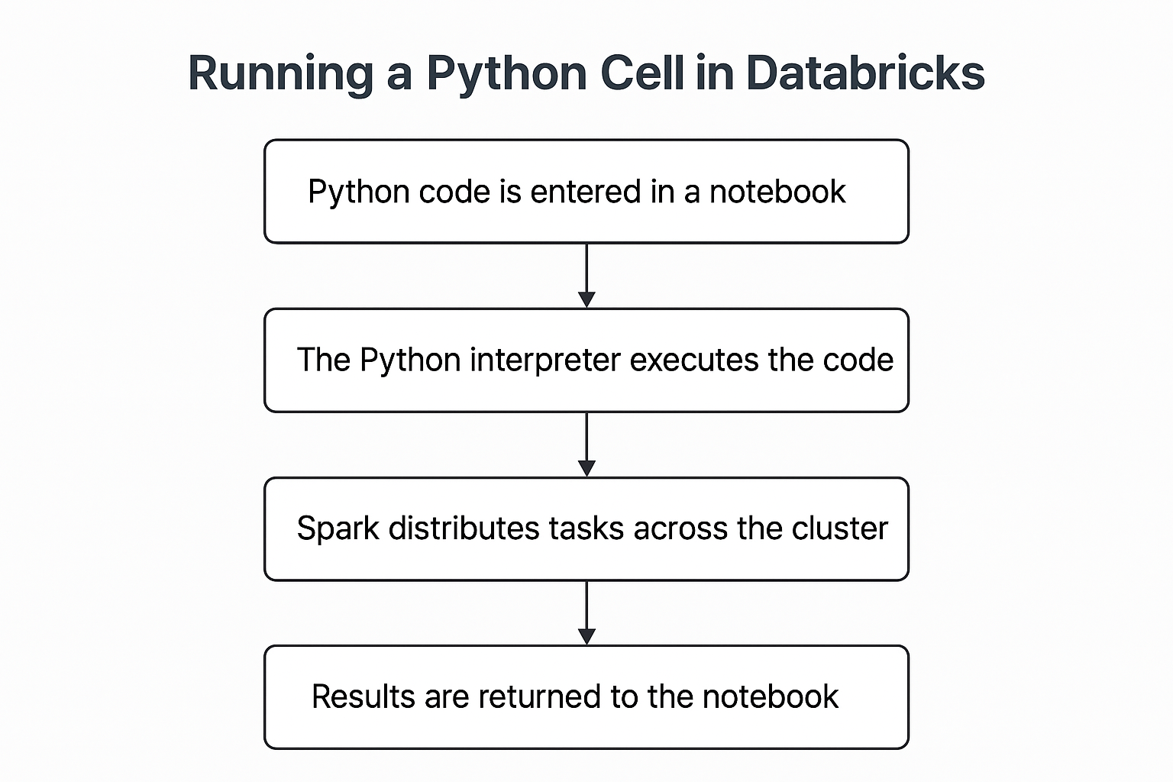
Here’s the step-by-step flow illustrated:
- Python code is entered in a Databricks notebook.
- The Python interpreter on the cluster executes the code.
- If using Spark, it distributes tasks across the cluster nodes for parallel processing.
- Results are returned to the notebook for display.

Clustered Node:-
In Databricks, a clustered node refers to the individual virtual machines (VMs) that make up a cluster. A cluster is a set of nodes used to run Apache Spark workloads, notebooks, jobs, and ML tasks.
Types of Nodes in a Databricks Cluster
- Driver Node
  - Acts as the master node.
  - Responsible for:
    - Running the Spark driver program.
    - Coordinating tasks across worker nodes.
    - Hosting the notebook interface.
  - Handles job scheduling and task distribution.
- Worker Nodes
  - Execute the actual Spark tasks.
  - Store data partitions in memory or disk.
  - Perform parallel computation.
  - Can scale up/down based on cluster configuration.
Cluster Characteristics
- Cluster Mode:
  - Standard: Driver and workers run in the same network.
  - High Concurrency: Optimized for multiple users.
  - Single Node: Driver and worker combined for lightweight tasks.
- Node Size:
  - Defined by VM type (CPU, memory, GPU).
  - Examples: Standard_DS3_v2 on Azure or m5.xlarge on AWS.
- Autoscaling:
  - Databricks can add/remove worker nodes dynamically based on workload.

